SOP – OEM integration with OLVM platform

OLVM Intergration With OEM 13c – (OLVM Monitoring)
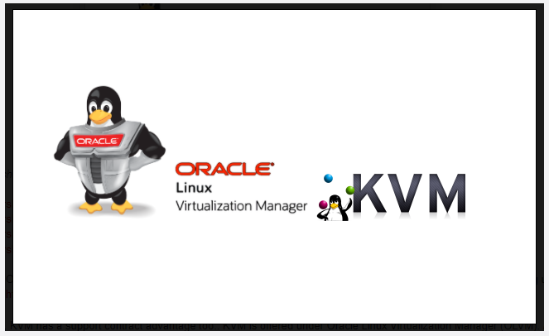

Introduction
Nowadays businesses heavily depend on online mission-critical databases and applications. The online market is 24X7 so it’s important they must be on top of the infrastructure monitoring. This helps system engineers, and database engineers to proactively react to alerts before they become major incidents. Monitoring and alerting play a vital role in enterprise IT infrastructure.
Companies are absorbing the Oracle virtualization platform to host their databases and applications. It’s of paramount importance to get alerts from the virtualization environment. Recently oracle integrate OLVM with oracle 13c OEM, which eases the administration overhead and helps the database administrators to manage infrastructure using the centralized console. Oracle 13c OEM is a well-mature product for monitoring and alerting, Also has many features and flexibility to tune the alerting as per the infrastructure.
In this article, I will cover the steps of how can we integrate OLVM with OEM13c.
You can refer oracle documentation link which has a step to integrate OLVM with 13c:
https://us.v-cdn.net/6032257/uploads/jive_attachments/0/2/0/02040254ydoByranib.pdf.
Pre-requisites for OLVM integration with OEM13c.
- Install the agent on the OLVM server
- Add Engine certificate to OEM trusted certificate list
- Provide the required information for registration

Registration Steps
As an initial step, make sure to have the oracle virtualization plug-in installed on the management server. If a plug-in exists push the agent to the OLVM server.
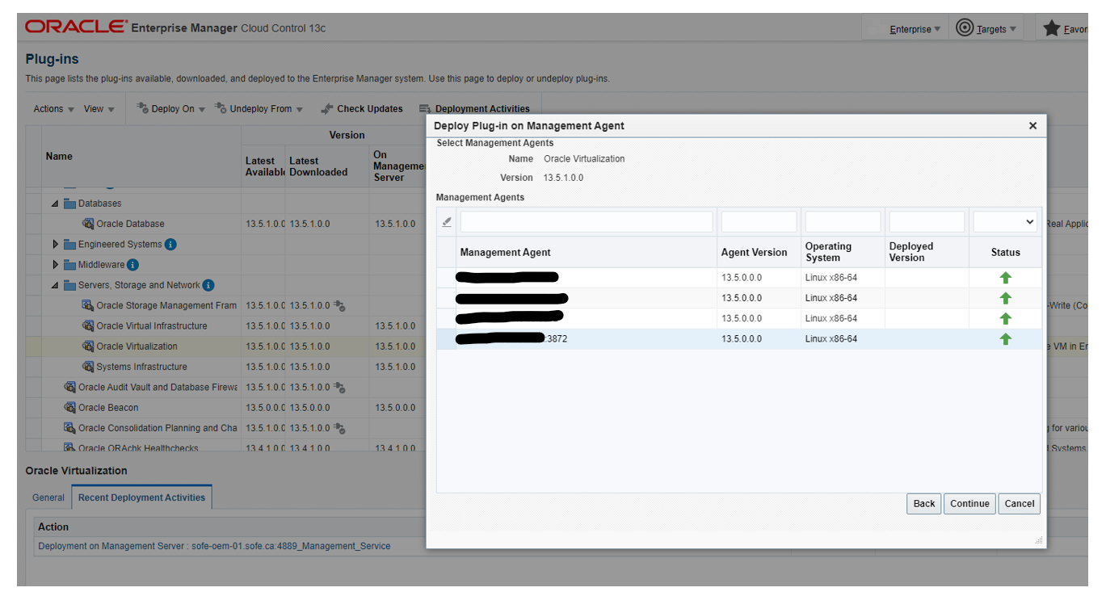

Successful registration should show the agent installation with the status green tik.
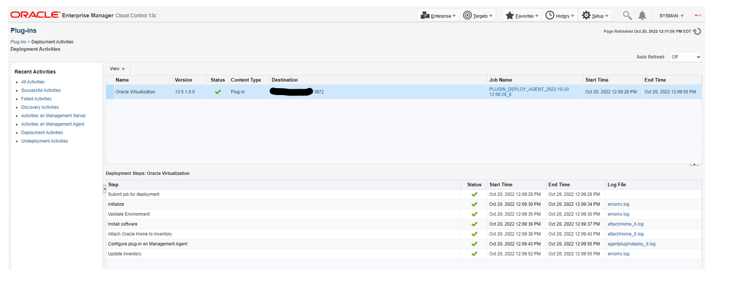
Once the agent installation is completed, download the Engine CA certificate from OLVM and copy it to the OEM server.
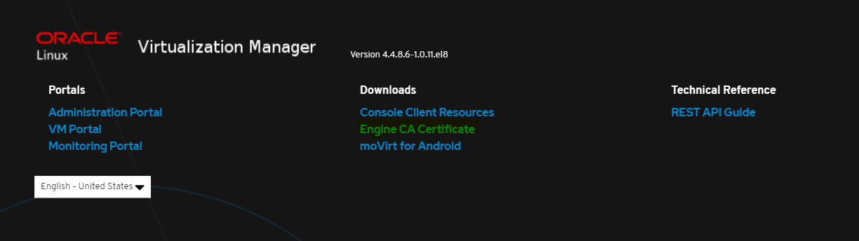

The next step is to add the key to OEM trusted certificate list by executing emctl secure add_trust_cert_to_jks -trust_certs_loc cert-location -alias NAME command.
There is a possibility of occurring an error if the registration password is incorrect. The correct password is there in oracle documentation.

Unsuccessful Registration
[oracle@localhost]$ /apps/orasoft/product/agent13c/agent_13.5.0.0.0/bin/emctl secure add_trust_cert_to_jks -trust_certs_loc /apps/orasoft/stage/OLVM-CRT/sofe-olvm-01.crt -alias SOFE-OLVM
Oracle Enterprise Manager Cloud Control 13c Release 5
Copyright (c) 1996, 2021 Oracle Corporation. All rights reserved.
Password:

Message : keytool error: java.io.IOException: Keystore was tampered with, or password was incorrect
ExitStatus: FAILED

Successful Registration
[oracle@localhost]$ /apps/orasoft/product/agent13c/agent_13.5.0.0.0/bin/emctl secure add_trust_cert_to_jks -trust_certs_loc /apps/orasoft/stage/OLVM-CRT/sofe-olvm-01.crt -alias SOFE-OLVM
Oracle Enterprise Manager Cloud Control 13c Release 5
Copyright (c) 1996, 2021 Oracle Corporation. All rights reserved.
Password:
Message : Certificate was added to keystore
ExitStatus: SUCCESS

Navigate to Enterprise > Cloud > Oracle Linux Virtualization Infrastructure.
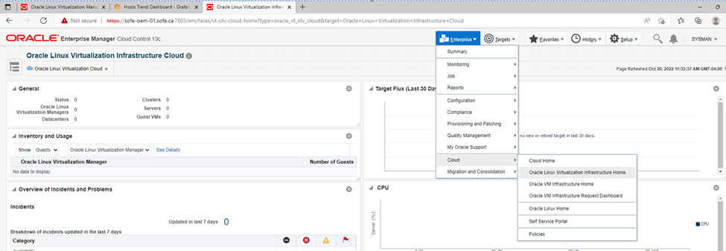
Figure 1: Show how you can navigate to the OLVM console.

Click the registration page and add the required information for registration.
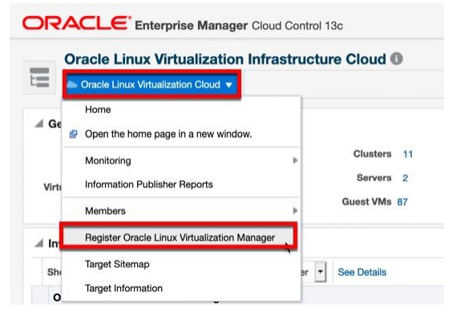
Figure 2: Navigate to the registration page

Feed information such as the NAME of the OLVM, select the monitoring agent, engine URL, and the admin password.
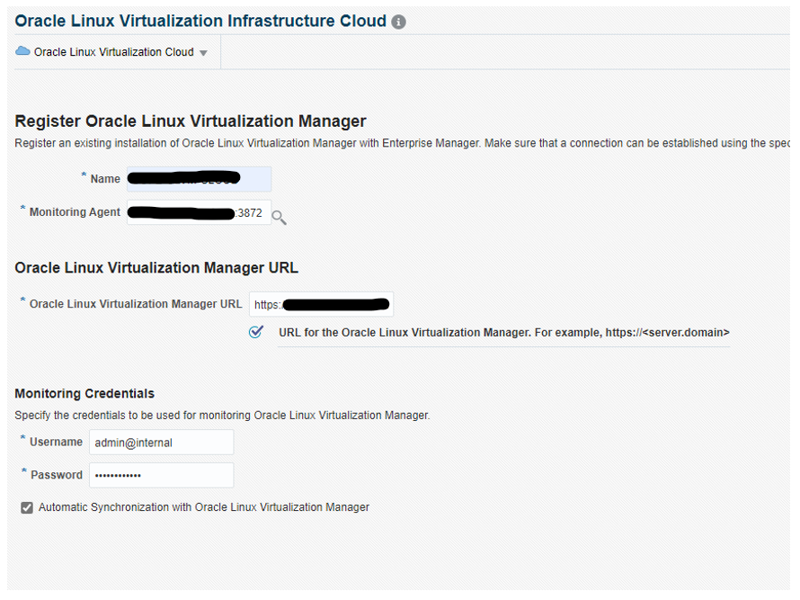
Figure 3: Registration page

Successful registration shows the Number of clusters, Datacenter, Servers, and VMs.
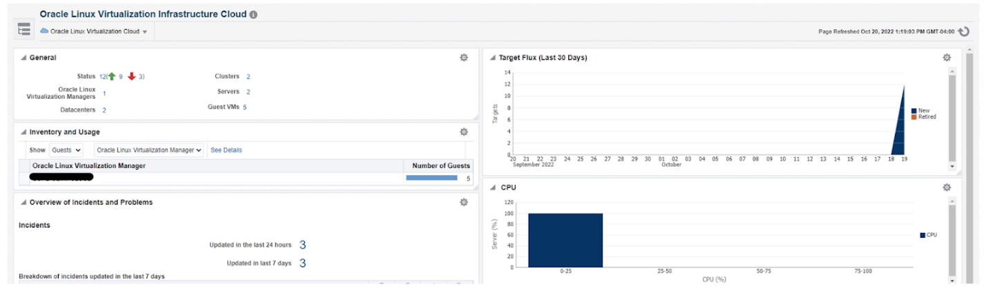
Figure 4: OLVM dashboard

This shows details information about the KVM server.
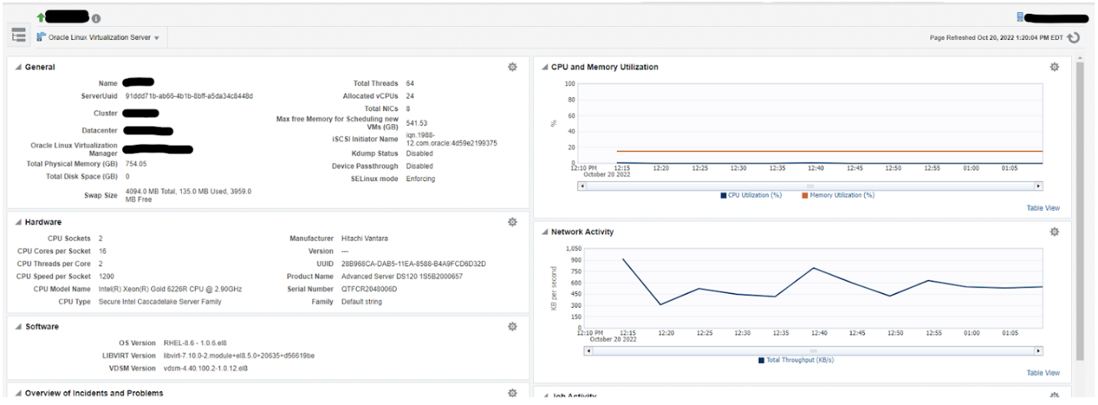
Figure 4: OLVM Dashboard

Conclusion
When organizations host databases and applications on oracle virtualized platforms like Oracle KVM with OLVM we need proper monitoring and alerting. In addition, organizations focus on reducing the administration overhead for monitoring tools. Integration of OEM13c with OLVM enables the path for proper monitoring via a centralized dashboard.

